St Michael’s Federation School Uniform
In our federation, we want our children to look smart and have an individual school identity. Please will you check that your child/children are wearing the correct uniform. We have designed our uniform to be smart, practical and reasonably priced.
Lydbury North C of E (A) Primary School and Nursery
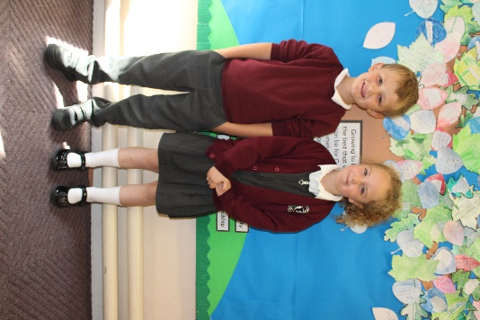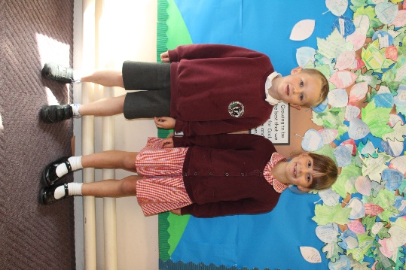
- Lydbury North School sweatshirt or cardigan or a plain burgundy sweatshirt or cardigan
- Black or grey trousers, shorts skirt or pinafore dress
- White polo shirt
- Black footwear (not trainers)
- Chequered summer dress in school colours
- Please can children with hair longer than shoulder length have their hair tied back at school. If children wish to wear headbands, bows and clips etc. - they should be of an appropriate size.

School PE Kit - kept in school every day
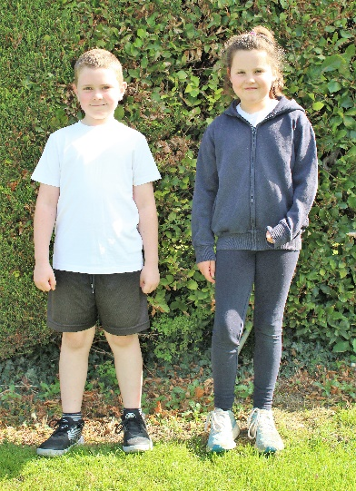
- White t shirt
- Navy blue or black shorts
- Navy blue or black bottoms and top
- Socks
- Trainers or pumps
- No jewellery is to be worn and if a child’s ears are pierced studs only may be worn (removed or taped during all PE and sport sessions)
Forest School Days
On forest school days the children may come to school in their forest school clothes. At forest school the children will need to wear:
- Trousers or warm jogging bottoms
- Sweatshirt or jumper
- Thick socks
- Wellington boots
- Waterproof coat
- Spare socks
Nursery
Children are welcome to wear school uniform if you wish, but nursery children can come in their own clothes. As their curriculum is very active and we work outdoors and paint every day it is best if the children are dressed in warm practical clothes that can be washed easily. Please would all nursery children have a change of clothes with them in a backpack each day.

